**System-Wide Requirements Specification – Appendix B - GUI Prototypes**

1. **Login Screens**

Template of web side;

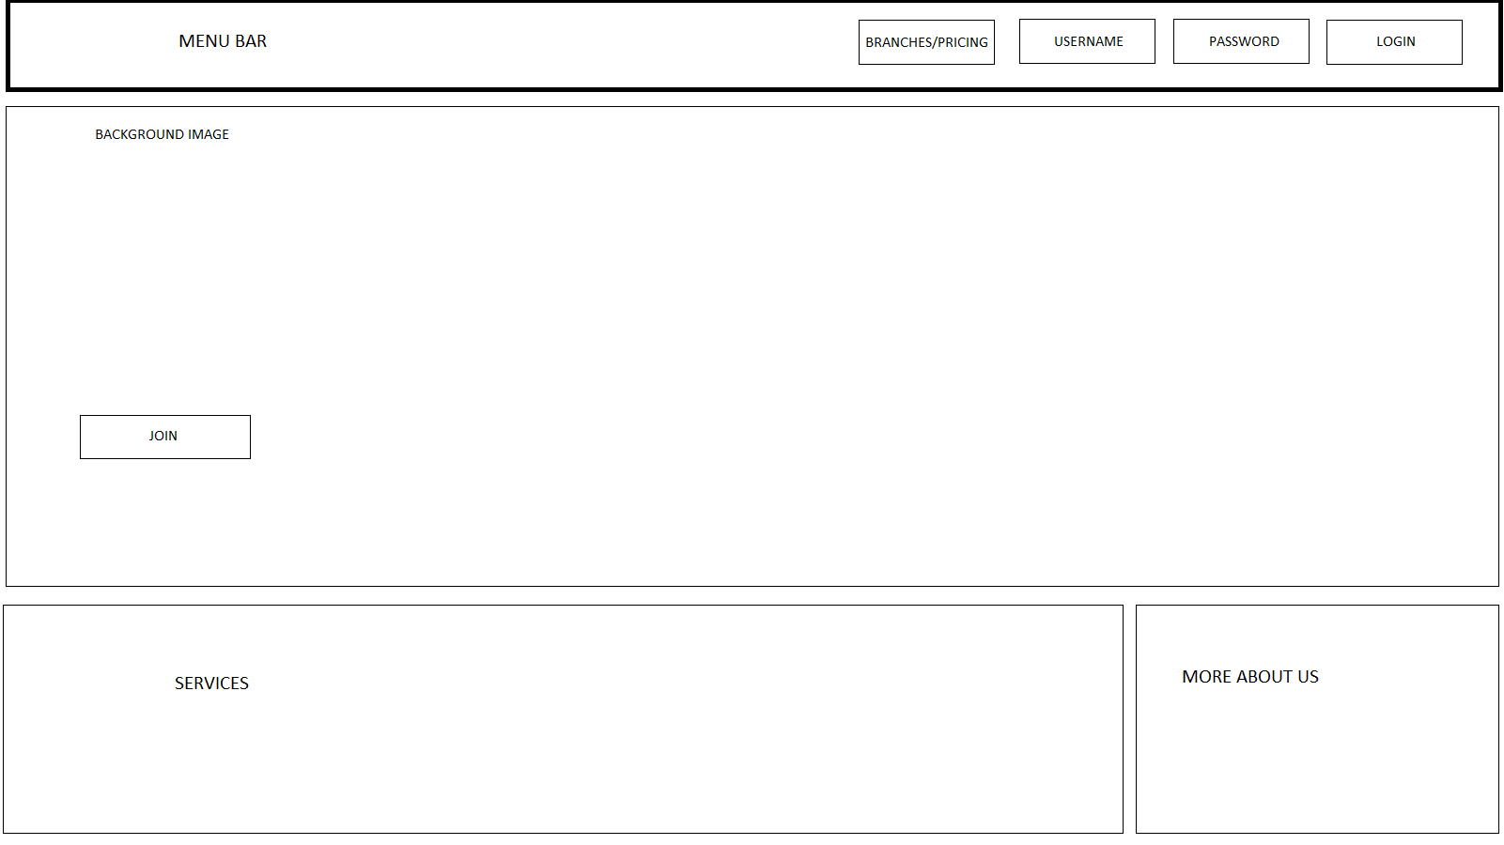

|  |
| --- |
| **Use Cases for both screens:**   * Login (SCMS-UC-02) * Register (SCMS-UC-01)   **For web side:**   * General Information (SCMS-UC-09) |

Template of mobile;



1. **Sign Up Screens**

|  |
| --- |
| **Use cases for both screens:**   * Register (SCMS-UC-01) |

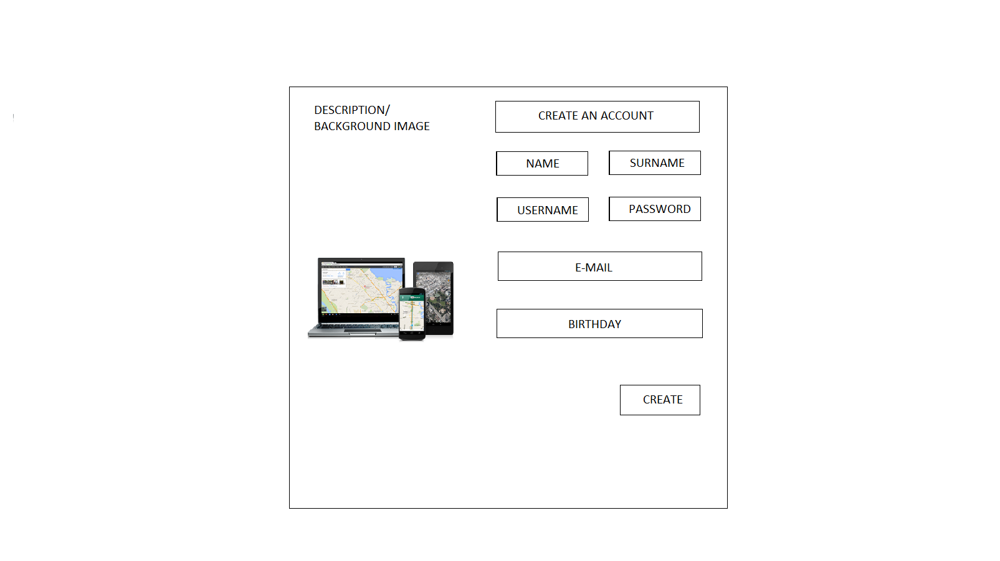

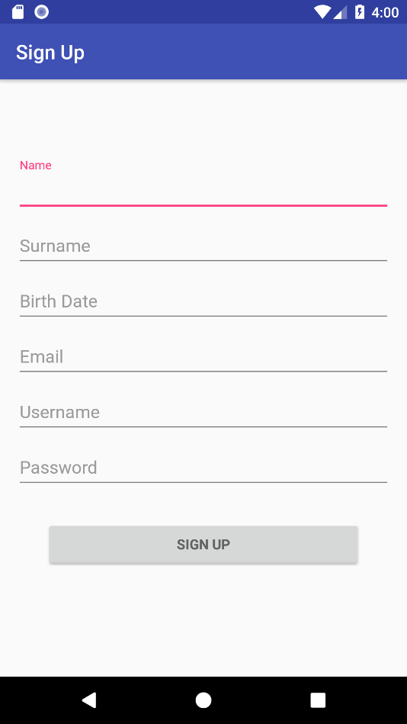

1. **Sign for Mobile**

|  |  |
| --- | --- |
|  | **Use case for the mobile side:**   * Login (SCMS-UC-02) |

1. **Home Screen for Web**

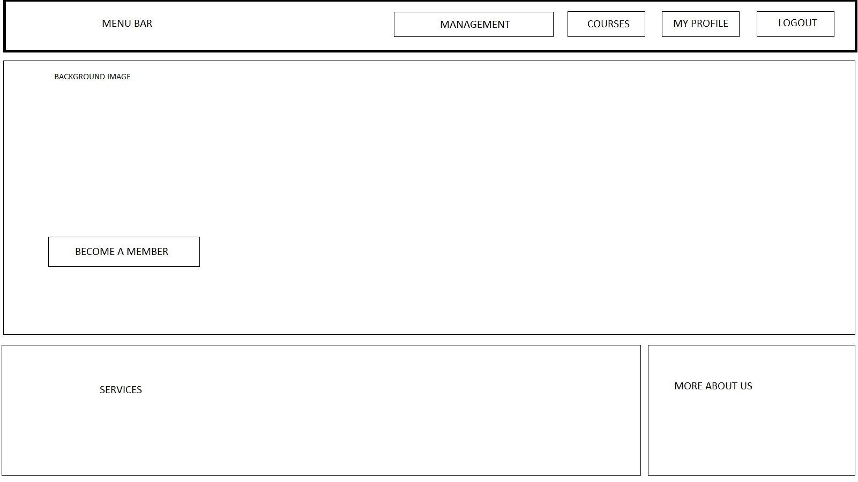

**Use cases for Web side:**

* Logout (SCMS-UC-03)
* Show User Profile (SCMS-UC-05)
* Show All Courses (SCMS-UC-11)
* Show General Information about sports center (SCMS-UC-09)
* All use cases for managing the sports center between SCMS-UC-14 and SCMS-UC-25
* Pay membership fee (SCMS-UC-04)

1. **Payment Screen for Web side:**

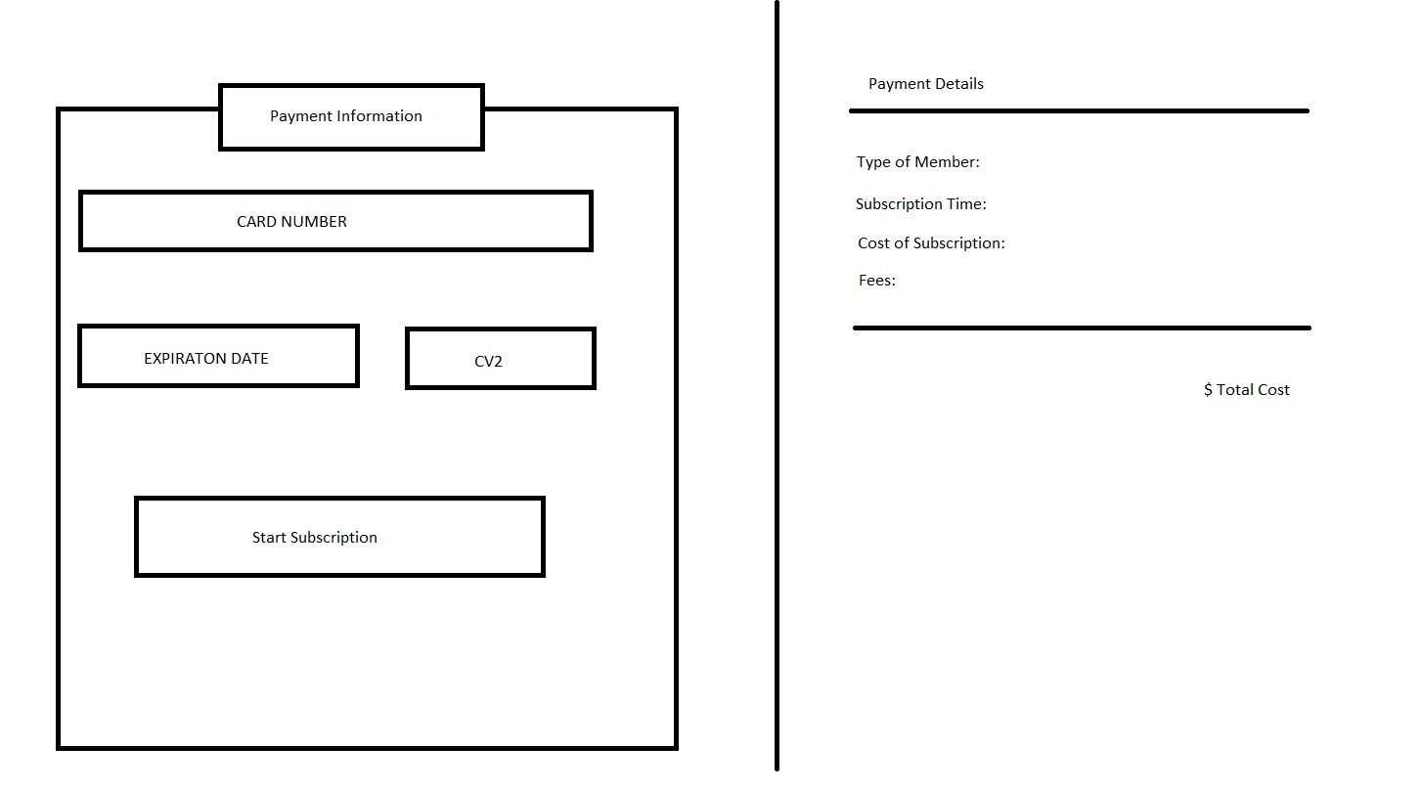

**Use Case for the web side:**

* Pay membership fee (SCMS-UC-04)
* Upgrade Membership Statue (SCMS-UC-10)

1. **User Profile**

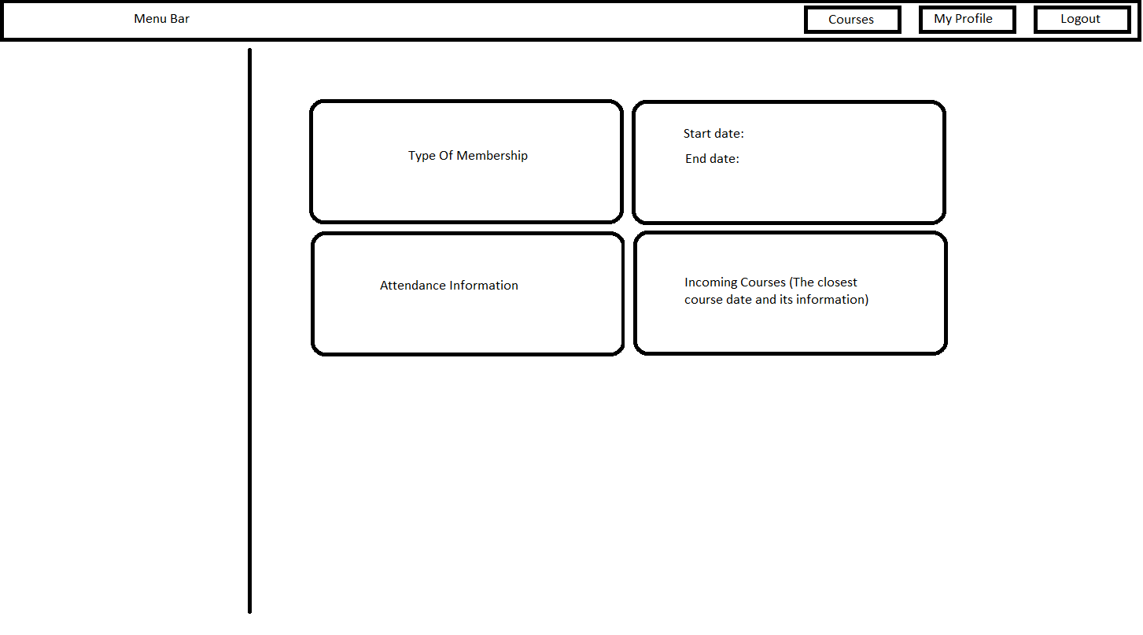

**Use Cases for the web side:**

* Logout (SCMS-UC-03)
* Show User Profile (SCMS-UC-05)
* Show All Courses (SCMS-UC-11)
* Upgrade Membership Statue (SCMS-UC-10)
* Show Joined Courses (SCMS-UC-05-2)